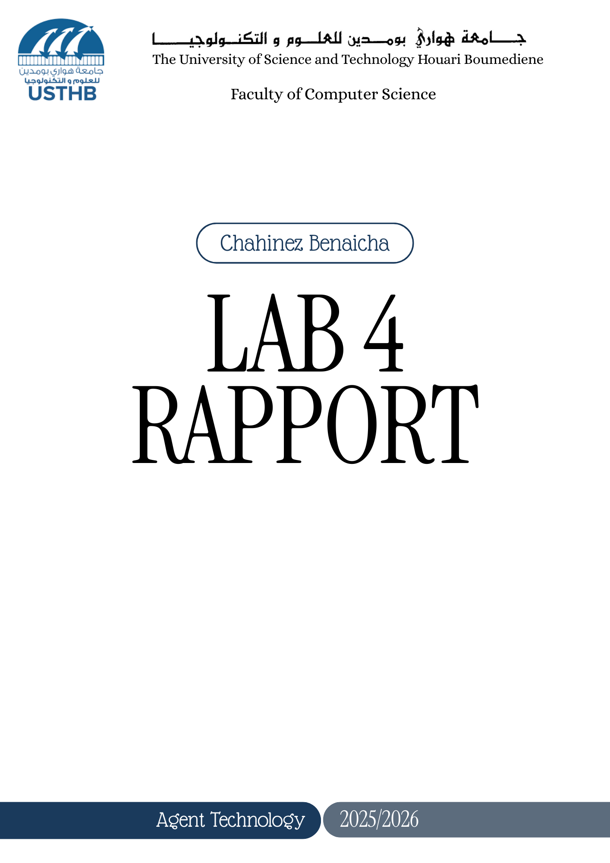
Behaviours in JADE

Exercise 1: Agent migration (mobile agent)
- Created an agent on a secondary container (container_2).
- Used the JADE GUI (RMA) to migrate the agent to the Main-Container.
- The agent displayed a message:
Before migration & During migration :
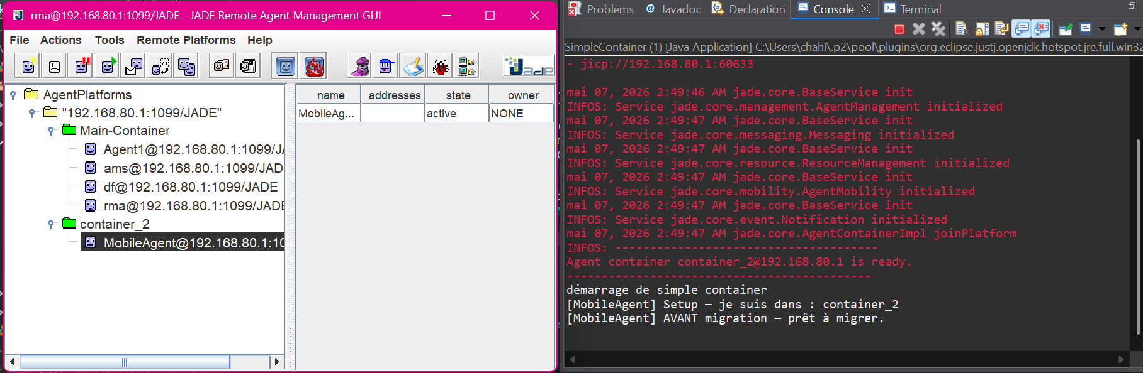
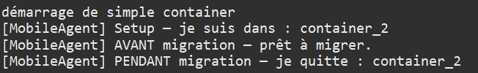
After migration
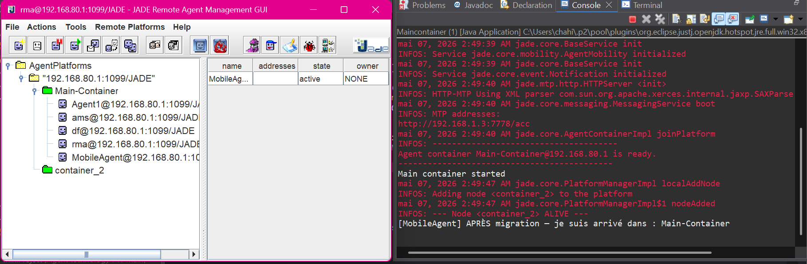

- This demonstrates JADE's support for mobile agents that can move between containers while preserving their state.

Exercise 2: Primitive behaviours
- Created an agent that runs several simple behaviours, each tested individually:
- Behaviour : loops until done() equals true.
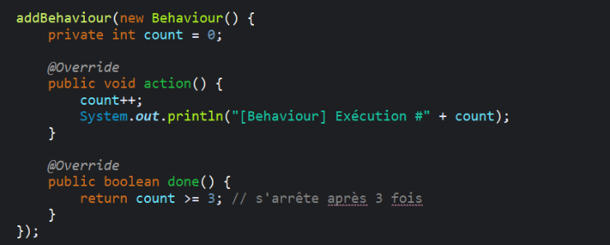
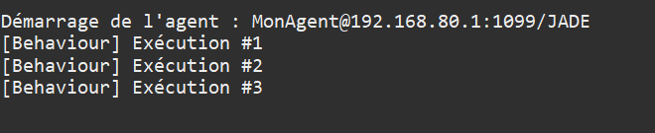

- OneShotBehaviour : executes once and terminates.
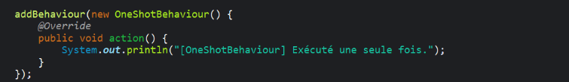
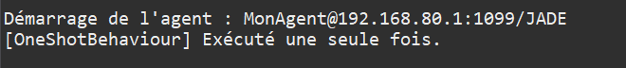
- CyclicBehaviour : executes repeatedly until agent kills it.
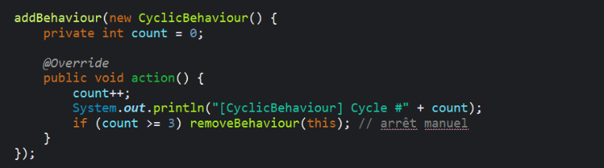
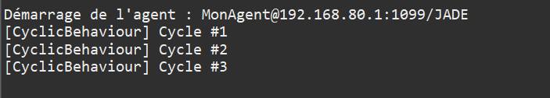
- WakerBehaviour : executes once after a specified delay.
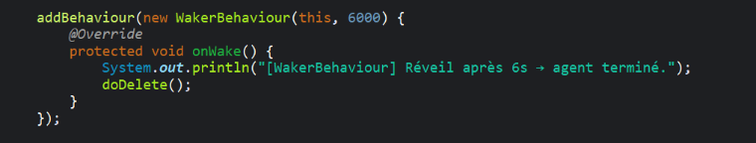
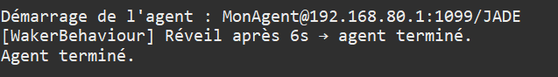
- TickerBehaviour : executes periodically at fixed intervals.
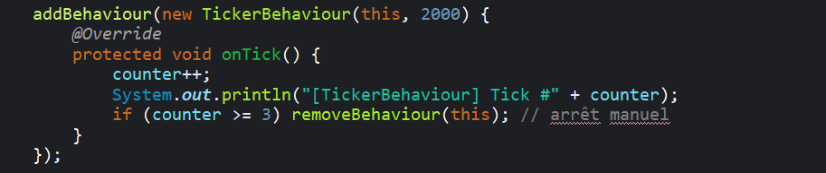
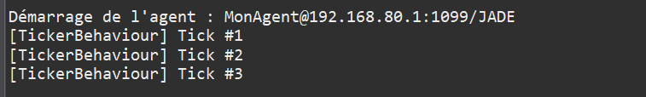

Exercise 3: Composite behaviour
- Created two agents (a1 and a2).
- Each agent owns multiple behaviours that execute in parallel. each behaviour is activated 3 times, and displayed greetings in several languages.
- Composite behaviours:
- ParallelBehaviour: executes multiple child behaviours concurrently.
- SequentialBehaviour: executes child behaviours one after another.
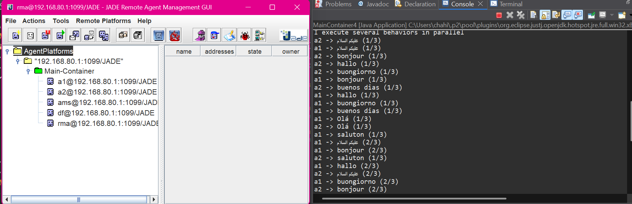

Conclusion
This lab provided a comprehensive understanding of behaviour-based agent programming in JADE. Primitive behaviours allow simple tasks, while composite behaviours enable sophisticated concurrency patterns.

